|  |  |
| --- | --- |
| Lamod, Shawn Michael L. | MACHINE PROBLEM 2 |
| COE60 – B1 | Prof. Carlos Hortinela IV |
| PROGRAM DOCUMENTATION | |

A. STARTING UP

To startup the program inside the folder and click CahsewWPF.exe.

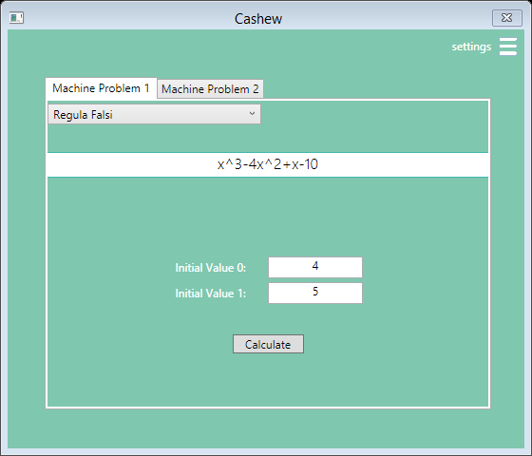

FIGURE 1: USER INTERFACE

B. SETTINGS

To set up the terminating conditions, segment sizes and step sizes of the program click the settings button and then enter the desired values and hit save.

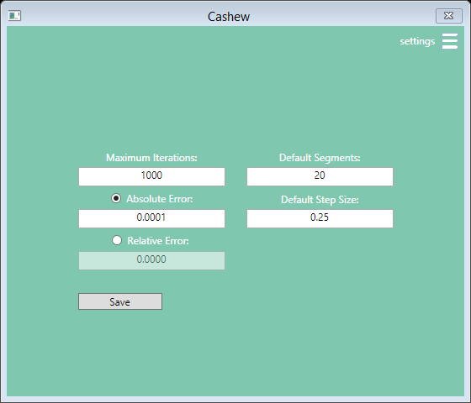

FIGURE 2: SETTINGS PAGE

C. MODE

The Program is divided into parts, to solve for the solution of an equation click the “Machine Problem 1” Tab, while Regression, Interpolation, Definite Derivatives and Integrals can be found on “Machine Problem 2”

D. MACHINE PROBLEM 2

🚩To find for the full list of available methods click down the drop down list found inside the upper left hand corner of the Machine Problem Tab

**Linear Regression**

To linearize a set of data points, Inside “Machine Problem 1” Select “Linear Regression”. Inside the tab input the “x” and the resulting “f(x)” data points to their respective textboxes.

❗ Input the points in the form: “[point], [point]”.

❗ Placement of the data points must be in the following fashion: “if $x=\{x_{0},x_{1},…x_{n}\}$ then $f\left(x\right)=\{f\left(x_{0},f\left(x_{1}\right),…f\left(x_{n}\right)\right\}$“

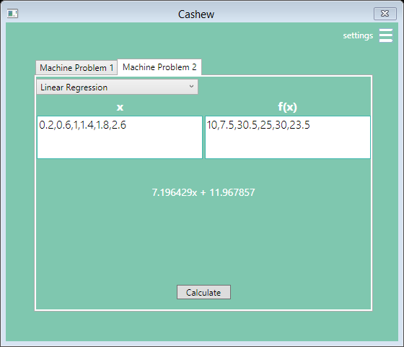

FIGURE 3: LINEAR REGRESSION

After Placing the appropriate values, hit calculate and the resulting linear equation will appear below the textboxes.

**Interpolation**

This program features function modelling using Newton’s Finite Divided Difference Interpolation Method. To proceed select “Newton’s Interpolation” in the drop down box.

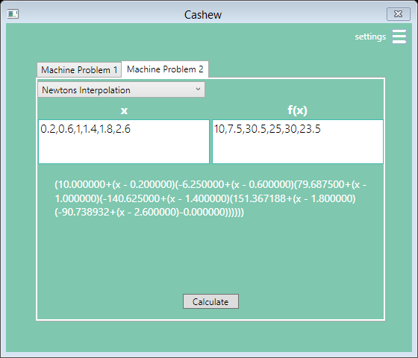

FIGURE 4: INTERPOLATION

Input the set of data points in the respective “x” and “f(x)” text boxes, (follow the same rules governing data input in linear regression) and then click “Calculate”.

A simplified version of the model function will appear below the 2 textboxes.

❗ Follow the procedures in the placement of data points in the same manner found in linear regression, the program may output erroneous results or the sentence “Sizes does not match” if it detects the number of data points in x does not match those in y.

**Integration**

Integration can be done either of the three methods namely “Trapezoidal Rule”, “One Third Rule”, “And Three Eights Rule”. In the Drop down box select an Integration Method.

In “The Machine Problem 2” Tab, 3 textboxes will appear. Input the expression to be integrated in the first textbox.

🚩 The program accepts algebraic and as well transcendental functions. Input them as you are evaluating expressions in MATLAB

Example:

sin(x)^2+(1/x)-10

✔ **Always Input your expression in terms of “x”, the program does not recognize variables rather than “x”.**

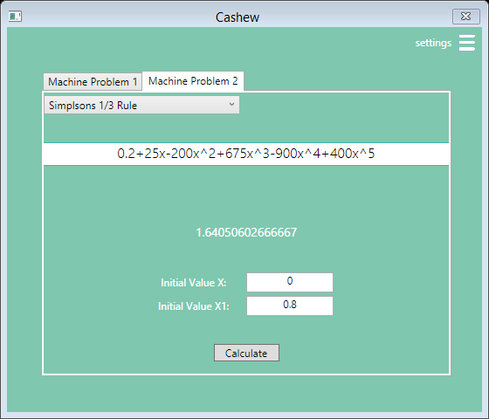

FIGURE 5: INTEGRATION

Input the Lower and Upper Limits of Integration in the Text boxes “Initial Value X” and Initial Value X1” respectively.

The Definite Integral will appear below the first textbox after clicking the button “calculate” in the bottom.

❗ Review the Default Step Size inside Settings, a large Step size will garner a more accurate result though will require more time to execute.

**Differentiation**

To solve for the definite derivative of an expression select one of the three methods found in the drop down box in the “Machine Problem 2” tab, namely “Forward FDD”, “Backward FDD” and “Centered FDD”.

After selection, Input the Expression to be differentiated in the upper text box, place the value x, in “Initial Value X” where the function is to be differentiated.

Click calculate and the resulting definite integral will be displayed in the bottom of the first textbox.

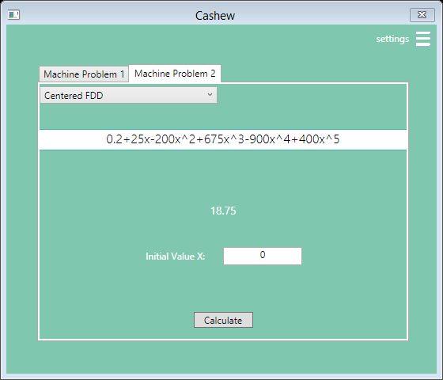

FIGURE 6: DIFFERENTIATION

❗ Check the default Step Size in the settings menu before clicking calculate to appropriate a more accurate definite derivative.

|  |  |
| --- | --- |
| Lamod, Shawn Michael L. | MACHINE PROBLEM 1 |
| COE60 – B1 | Prof. Carlos Hortinela IV |
| PROGRAM DISCUSSION | |

A. LINEAR REGRESSION

Linear regression is a method used to fit a straight line of ordered pairs, wherein it can be used to predict intermediate values. This is typically used in experimental data to determine and or verify the relationship between two variables. The mathematical expression for the straight line is defined by:

$$y=a_{0}+a_{1}x+e$$

Where a0 and a1 are coefficients representing the intercept and the slope, respectively, and e is the error, or residual.



FIGURE 1: LINEAR REGRESSION

Using a maxima minima criterion for fitting a best line and minimizing the sum of the squares of the residuals between the measured y and the y calculated with the linear model will yield a0 and a1 to be:

B. INTERPOLATION

Polynomial interpolation consists of determining the unique nth-order polynomial that fits n+1 data points. This polynomial then provides a formula to estimate intermediate values.

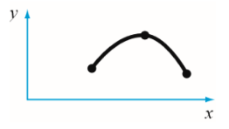

FIGURE 2: POLYNOMIAL INTERPOLATION

Newton’s divided-difference interpolating polynomial is among the most popular and useful form for expressing an interpolating polynomial.

We express the nth order polynomial to be in the form of:

$$f_{n\left(x\right)}=b_{0}+b_{1}\left(x-x_{0}\right)+…+b_{n}\left(x-x_{0}\right)\left(x-x_{1}\right)…\left(x-x_{n}-1\right)$$

Where

$$b_{n}=f[x_{n},x_{n-1},…,x_{1},x_{0}]$$

$$f\left[x_{n},x_{n-1},…,x_{1},x_{0}\right]=\frac{f[x_{n},x_{n-1},…,x_{1}]-f[x_{n-1},x_{n-2},…,x_{0}]}{x_{n}-x_{0}}$$

C. INTEGRATION

Numerical integration schemes is based on the strategy of replacing complicated functions with an approximating function that is easy to integrate.

**TRAPEZOIDAL RULE**

The trapezoidal rule is the first of the Newton-Cotes closed integration formulas. It corresponds to the case where the polynomial in is linear.

$$I=\left(b-a\right)\frac{f\left(a\right)+f\left(b\right)}{2}$$

To improve the accuracy of the trapezoidal rule divide the integration interval from “a” to “b” into a number of segments “n” and apply the method to each segment.

$$h=\frac{b-a}{n}$$

The areas of individual segments can then be added to yield the integral for the entire interval.

$$I=\frac{h}{2}[f\left(x_{0}\right)+2\sum_{i=1}^{n-1}{f\left(x_{i}\right)}+f(x_{n})]$$

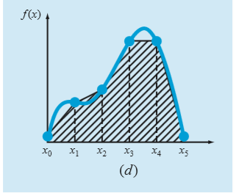

FIGURE 3: MULTIPLE APPLICATIONS OF TRAPEZOIDAL RULE

**SIMPSON’S 1/3 RULE**

Another way to obtain a more accurate estimate of an integral is to use higher-order polynomials to connect the points.

Simpson’s 1/3 rule results when a second-order interpolating polynomial is substituted into the general integration formulae, which will result into:

$$I=\left(b-a\right)\frac{f\left(x_{0}\right)+4f\left(x_{1}\right)+f(x_{2})}{6}$$

Just as with the trapezoidal rule, the integral estimate can be improved by dividing the integral interval into a number of segments of equal width. The general formula for the 1/3 rules with multiple applications is as follows.

$$I=\frac{h}{3}[f\left(x_{0}\right)+4\sum_{i=1,3,5}^{n-1}{f\left(x_{i}\right)}+2\sum_{i=2,4,6}^{n-2}{f\left(x_{i}\right)}+f(x_{n})]$$

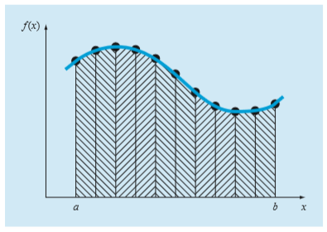

FIGURE 4: MULTIPLE APPLICATIONS OF SIMPSONS 1/3 RULE

However it must be noted that the multiple application of the 1/3 rule can only be valid if the number of segments is even.

**SIMPSONS 3/8 RULE**

The derivation for the 3/8 rules is of similar manner in the trapezoidal and 1/3 rule, however a third order polynomial is used to fit four points and integrated.

$$I=\left(b-a\right)\frac{f\left(x_{0}\right)+3f\left(x_{1}\right)+3f\left(x_{2}\right)+f(x_{3})}{8}$$

Though the Simpsons 1/3 rule is the method of preference in solving for the Integral Estimate, the Simpsons 3/8 rule has utility when the number of segments is odd.

D. DIFFERENTIATION

Due to the Nature of the Taylor Series (representation of a function as an infinite sum of the function’s derivative at a point), It is extensively used to develop formulas to approximate derivatives numerically.

We define a Taylor series expansion as:

$f\left(a\right)= f\left(a\right)+f^{'}\left(a\right)\left(x-a\right)+\frac{f^{''}\left(a\right)}{2!}{\left(x-a\right)}^{2}+…$

**FORWARD FINITE DIVIDED DIFFERENCE**

Solving for the Derivative Estimate of a function is based from the relationship:

$$f\left(x_{i+1}\right) ≅f(x_{i})$$

Wherein it indicates that the value of f at the new point is the same as its value at the old point. Substituting it to a first order term of the Taylor series will yield:

$$f\left(x_{i+1}\right) ≅f\left(x_{i}\right)+ f^{'}\left(x_{i}\right)\left(x_{i+1}-x_{i}\right)$$

And solving for $f'(x_{i})$ would yield to what is called as a finite divided difference.

$$f^{'}\left(x_{i}\right)=\frac{f\left(x_{i+1}\right)-f\left(x_{i}\right)}{x_{i+1}-x_{i}}$$

**BACKWARD FINITE DIVIDED DIFFERENCE**

The Taylor series can be expanded backward to calculate a previous value on the basis of a present value.

$$f\left(x_{i-1}\right) ≅f\left(x_{i}\right)- f^{'}\left(x_{i}\right)\left(x_{i-1}-x_{i}\right)$$

Which would yield to:

$$f^{'}\left(x_{i}\right)=\frac{f\left(x_{i}\right)-f\left(x_{i-1}\right)}{x_{i}-x_{i-1}}$$

**CENTERED FINITE DIVIDED DIFFERENCE**

A third way to approximate the first derivative is to subtract the backward Taylor series expansion from the forward Taylor series expansion, to which would result to:

$$f\left(x_{i+1}\right)=f\left(x_{i-1}\right)+ 2f^{'}\left(x_{i}\right)\left(x_{i+1}-x_{i-1}\right)$$

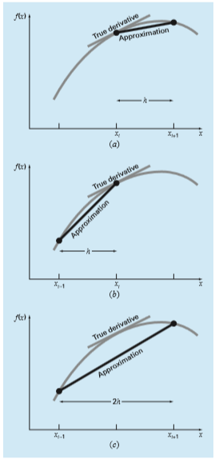

FIGURE 5: GRAPHICAL REPRESENTATION OF FORWARD, BACKWARD, CENTERED FDD RESPECTIVELY.